**letsupgrade**

**Cybersecurity Essentials**

**Assignment Day 4 / 23rd August 2020**

Name – akhil gudimalla

Email Id: - gakhil9201@gmail.com

Mobile no 6301884795

**Q**1. Find out the mail servers of the following domain:

* Ibm.com
* Wipro.com

Sol-

Step 1 first open command prompt

Step 2 type nslookup

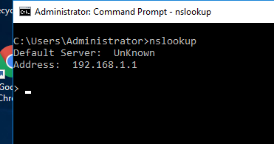

Step 3 then type “set type=mx” nd then site name that you are looking

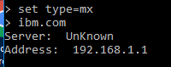

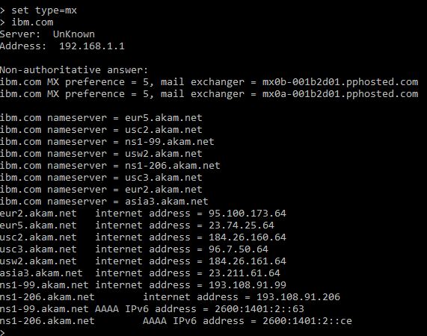

Step 4 same for wipro.com.

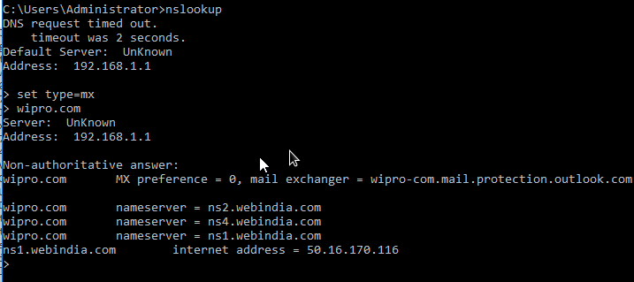

**Q**2. Find the location, where these email servers are hosted.

Sol. To find location of these email servers we have to get an email from site. To do so we can register on one of the sites ibm.com.

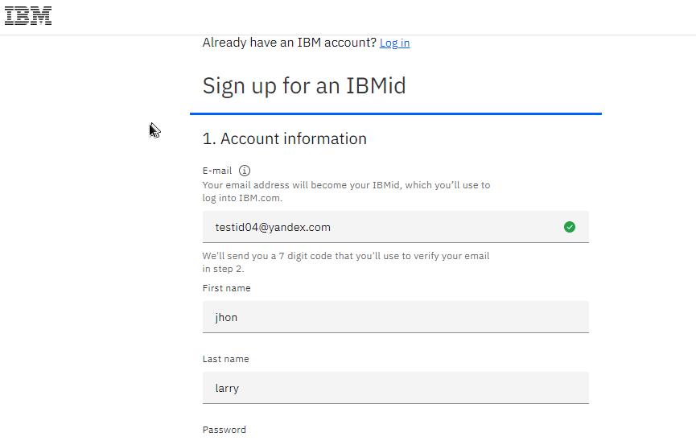

Open Gmail after getting confirmation mail from IBM.



Open mail. And choose show original option.

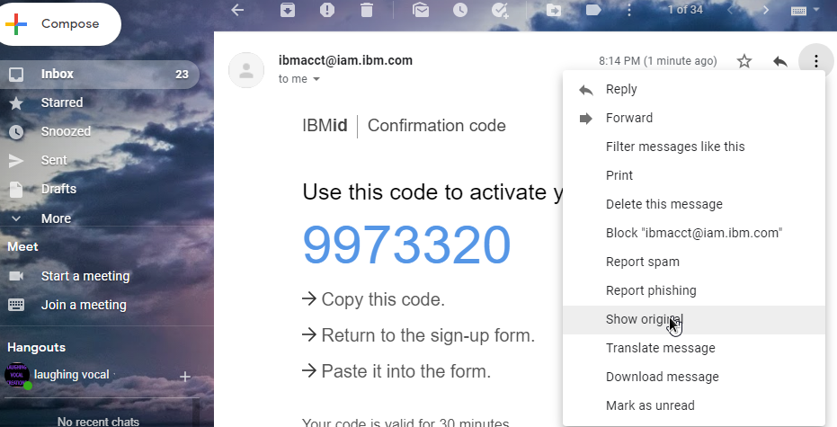

Open email tracer and chose option trace headers.

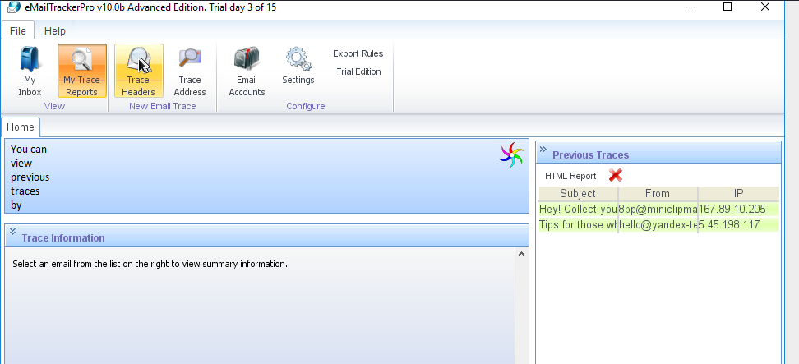

Open mail and select option copy to clipboard and paste it in email tracer.

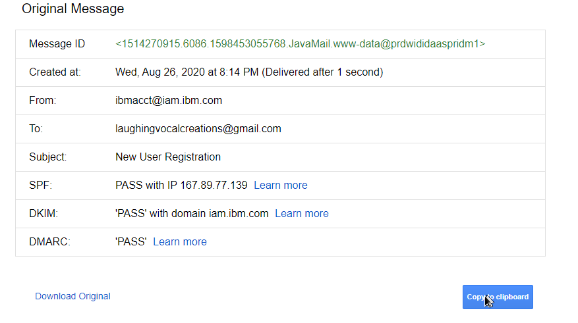

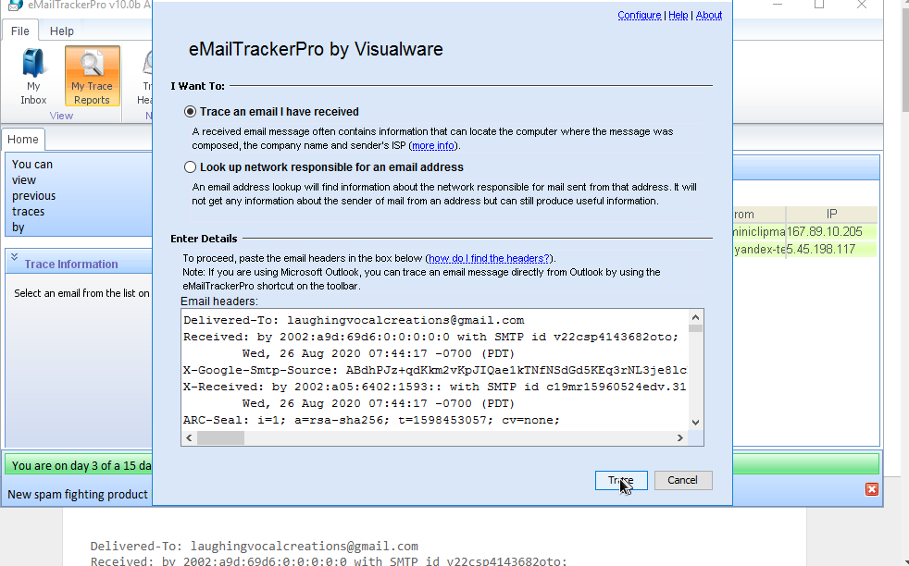

And press trace.

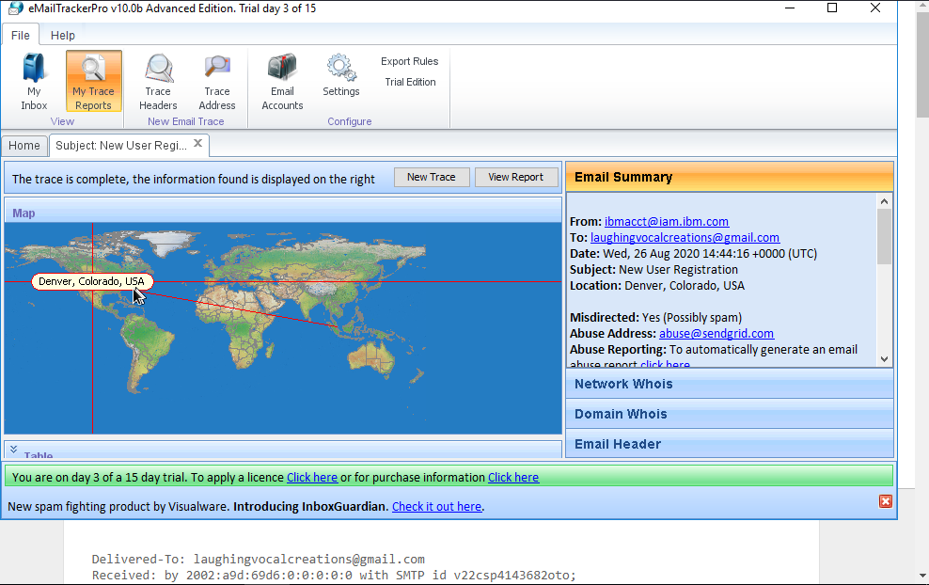

And we get the location i.e. Denver, Colorado, USA.

Or we can use website i.e. my-addr.com

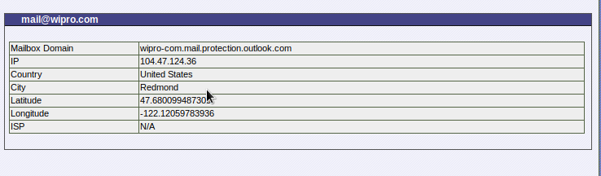

We get result for wipro.com i.e. Redmond, us.

**Q**3. Scan and find out port numbers open 203.163.246.23.

Sol. To scan port, we use Nmap.

1. We use kali Linux.
2. Open terminal in kali Linux and type command “nmap [www.ibm.com](http://www.ibm.com) -p 203,163,246,23”

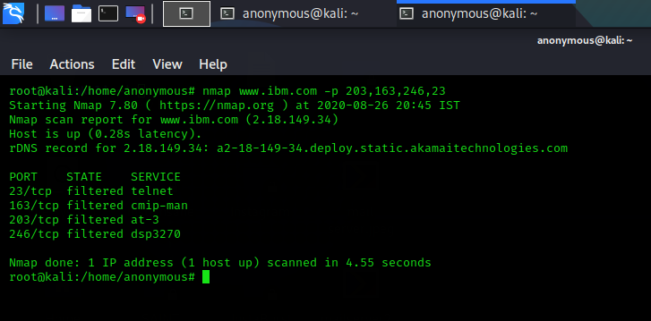

1. As we can see all given ports are filtered or we can say protected by firewall.
2. Doing same for wipro.com.

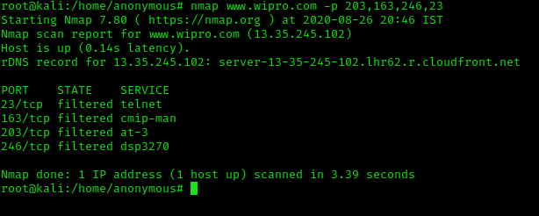

1. As we can see ports given above are also filtered in wipro.com.

**Q**4. Install Nessus in a VM and scan your laptop/desktop for CVE.

Sol.

1. Install Nessus in your virtual machine open it .

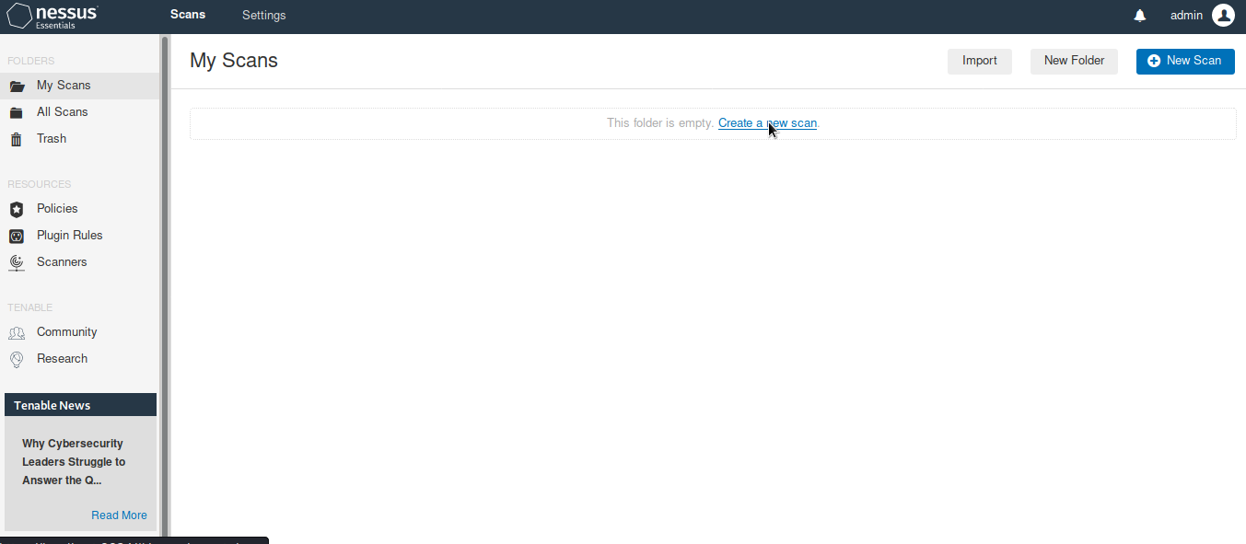

1. Click on new scan.
2. Then click on advance scan .

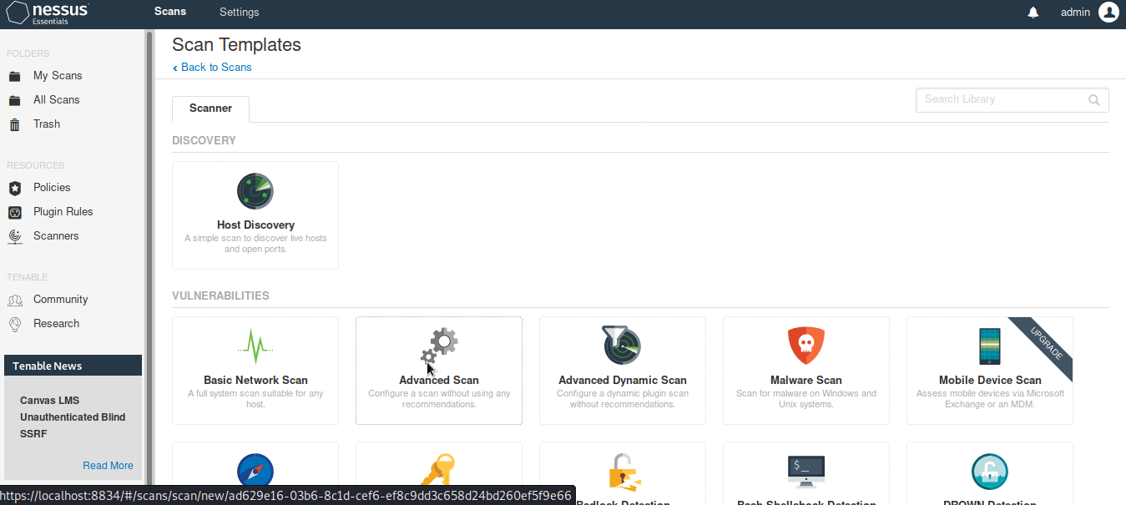

1. Now, fill name description and target ip which is 192.168.1.101 in this case.
2. And then click on scan.

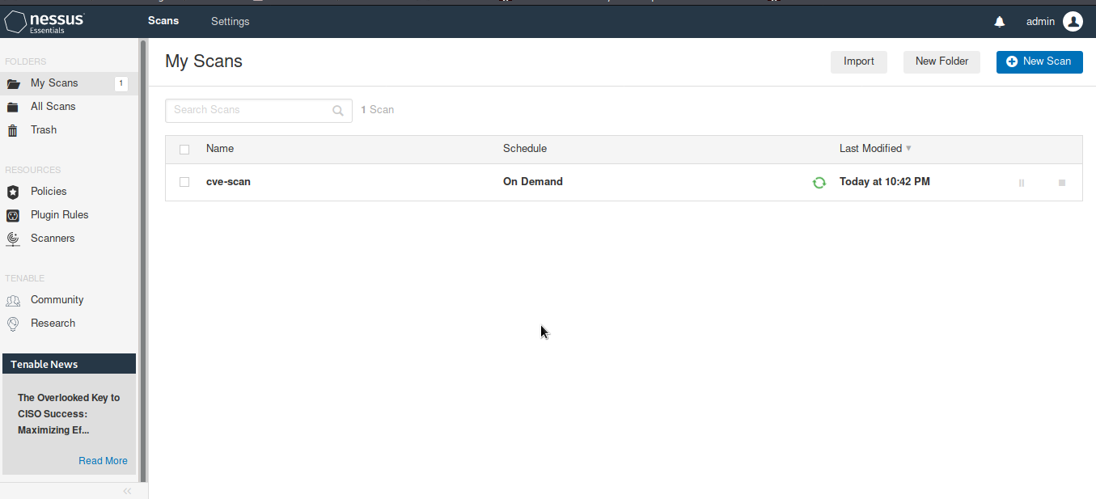

1. After scan complete we can see all the vulnerabilities index as –

* Critical
* High
* Medium
* Low
* Info

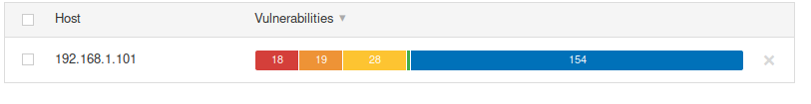

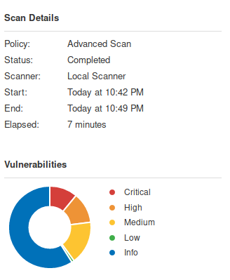

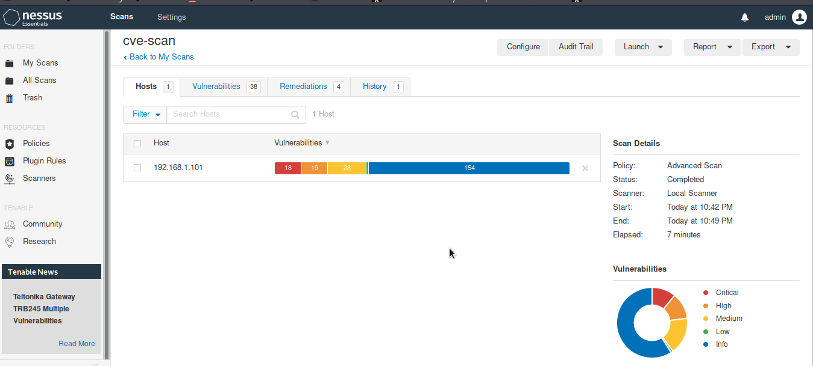

As we can see we have –

* 18 critical
* 19 high
* 28 medium vulnerabilities.